

**DEPARTMENT OF CIVIL ENGINEERING**

**SHC 798**

**APPLIED STATISTICAL METHODS AND OPTIMISATION**

**RICHARD LUBEGA**

*Full names*

**25585089**

*Student number*

**1**

*Assignment*

# DECLARATION

1. I understand what plagiarism is and am aware of the University’s policy in this regard.
2. I declare that this submission is my original work. Wherever other people’s work has been used (either from a printed source, the internet or any other source) this has been properly acknowledged and referenced in accordance with departmental requirements.
3. I declare that I did not use ChatGPT or similar AI-based tools to prepare this report.
4. I have not used another student’s current or past written work to hand in as my own.
5. I have not allowed and will not allow anyone to copy my work to pass it off as his or her work.

Signature: 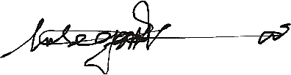

Date: 14-07-2025